CS4332.501

12/09/16

Project Final Report

Project Name: **Sparrow**

Team Members: David Dillard, Jared Hull

Game story / Set Up

You are a fighter pilot on your ship: SPARROW. You have just awoken from hyper sleep after an incorrect phase jump. You don’t know where you are or what year it is, and are struggling to remember what your mission was. On your screen ahead of you, you see a planet a few thousand clicks away. You scan your inventory and see that all major systems are online, but your shield and guns are barely charged, and you’ll need to collect more matter for them to work correctly again. Your scanner detects multiple objects on a path to intercept you, as you make your way towards the planet…

Outline of the game

This is a scrolling shooting game, where you take the role of a ship, the SPARROW. The game scrolls past, as a character you have limited forwards/back movement, but can dodge horizontally away from oncoming enemies. I am attempting to make this game with a variety of enemies, with some environmental hazards that you will have to dodge. Your shields are not working well, and the time increase to the next shield increases every time you deploy your shield. The game will be an endless shooter, with the goal of either reaching a high score or in staying alive for the longest time. Enemies endlessly try to kill you, in increasingly harder waves.

Project Milestone Dates

Biggest Accomplishment

I believe our biggest accomplishment was getting the shield to work, and implementing all of our tags. The shield was extremely hard to implement correctly – the timing wasn’t working, because we kept calling the StartCoroutine from Update, instead of from Start. This called it multiple times, and with a constant set time increase, it kept increasing, and then the x+1 IEnumerator would start, etc. The tags took longer due to silly mistakes with failing to differentiate between local and global tags. Getting this done correctly was something I’m very proud of, and glad to have finished.

Work Breakdown

|  |  |  |  |  |  |  |  |
| --- | --- | --- | --- | --- | --- | --- | --- |
| **Assignee,**  **Worker (final)** | **ID** | **Task** | **Name** | **Planned Duration (Hours)** | **Actual Time Duration (Hours)** | **Description** | **Notes** |
| David,  D | 1 | 1 | Project Selection | 1 | 1 |  |  |
| David,  D + J | 2 | 1.1 | Formal Project Proposal | 2 | 4 |  |  |
| David,  D | 3 | 1.1.1 | Game Story | 0.5 | .5 |  | This finished on time! Huzzah! |
| Jared,  J + D | 4 | 1.1.2 | Gameplay ideas | 1 | 1.5 |  |  |
| Jared,  J | 5 | 1.1.3 | Milestone Breakdown | 1 | 1 |  |  |
| David,  D | 6 | 1.2 | Technical Design | 2 | 3 |  |  |
| Jared,  D | 7 | 1.2.1 | Work Breakdown | 1 | 1 |  |  |
| David,  D + J | 8 | 1.2.2 | Code Structure | 2 | 1 |  |  |
| Jared,  D + J | 9 | 2 | Main game logic | 21 | 22 | Ongoing |  |
| Jared,  J | 10 | 2.1 | Movement | 2 | 4 | Physics for player, enemies |  |
| David,  J | 11 | 2.1.1 | Player movement | 3 | 6 | Horizontal dodging + limited forward / backwards |  |
| David, | 12 | 2.2 | Menus | 1 | .2 | Ended up with a very simple GUIText | Needed to be radically simplified |
| David,  D | 13 | 2.3 | Enemy behavior (AI) | 4 | 1 | Basic avoidance, movement patterns | Making good progress, but slow |
| Jared,  J | 14 | 2.3.1 | Enemy movement | 4 | 2 | Same basic movement type |  |
| Jared,  J | 15 | 2.3.2 | Enemy non-movement | 2 | 1 | rocks, debris | May cut back due to time |
| Jared | 16 | 2.4 | Procedural map generation | 5 | 0 | Tiled map setup | Canceled |
| David | 17 | 3 | Character creation | 2 | 0 | Possibly dynamic | Scrapped |
| David,  D | 18 | 3.1 | Map backgrounds | 1 | 2 | Static images (possibly large image with scroll) | Spent a lot of time working on scrolling, did not work because background texture was wrong |
| David,  D | 19 | 3.2 | Object textures | 3 | 3 | Spritesheets | Imported a lot from the asset store |
| Jared | 20 | 4 | Environmental hazards | 1 | 10 | Debris and rocks, map walls | Spent a long time on this |
| Jared | 21 | 4.1 | Player upgrades | 2 | 0 | First goal: single upgrade. Second goal: upgrade tree | Removed, replaced with variable for longer time delay on shields |
| David,  D + J | 22 | 5 | Sounds and visuals | 2 | .5 | Extras, add after basic functionality | Imported a lot from the asset store |
| Jared,  D | 23 | 6 | Prototype Demo prep | 1 | 1 |  |  |
| David,  D | 24 | 6.1 | Progress report | 2 | 1 |  |  |
| Jared | 25 | 7 | Final Demo prep | 1 | 1 |  |  |
| Total: |  |  |  | 67.5 | 67.7 |  |  |

Any and all changes in plan since your beta report

Changes in structure:

We got rid of all the AI for the enemies, relying on basic move (linear horizontal movement, with some additional vertical variation for some game enemies). We scrapped the random map generation, instead switching to an endless side-scroller. We got rid of the random environmental hazards, everything is just an enemy object that gives points, asteroids, meteors, etc. Most of the art assets were from the Unity Asset store, for free. We got rid of all menus, except the opening game introduction screen. We did actually adhere pretty well to most of our original proposal, with the exception of more of our stretch goals, like random generation (although this is represented in the random hazard spawning off screen).

Changes in scheduling:

Most everything was pushed off to the last two weeks, due to massive work required for our software engineering capstone class. Due to this, most of our scheduling from the beta report was totally disregarded. Had we time, it would have been better to start from the beginning, and actually hit all of our goals. We did not adhere well our original proposal timeline.

Summary of Experience with this project

We learned quite a bit about Unity, a ton about game development. Particularly, we learned a lot about Coroutines, and about spawning and destroying all our cloned game objects. If we had to do it again, we would have focused more on the enemy behavior, because we think this is an underdeveloped part of this game. We are happy with the experience spawning waves of enemies, using a variety of enemy types, and using a variety of effects on enemy action. Particularly, enemy lasers and player lasers behave differently, different kinds of enemies respond to different effects, some destroy other objects, some are simply deflected in the 3D playing field, and the large meteor responds to only a player laser or player object contact, spawns a clone of an explosion sound and image, and then loops through an iterator to spawn multiple small enemies, each responding to the 3D motions of the other objects, each spawning at tiny random intervals on the x and z axis.

Technical Specifications

OS: Windows 10

Controller Types: Mouse and Keyboard

Amount of Disk Space Required: 400mb

Screenshots

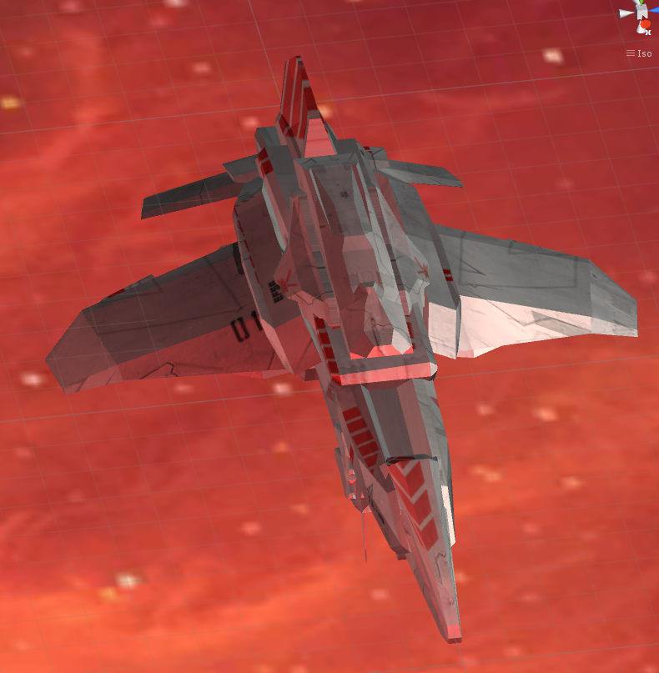

Figure 1 Main Player Object

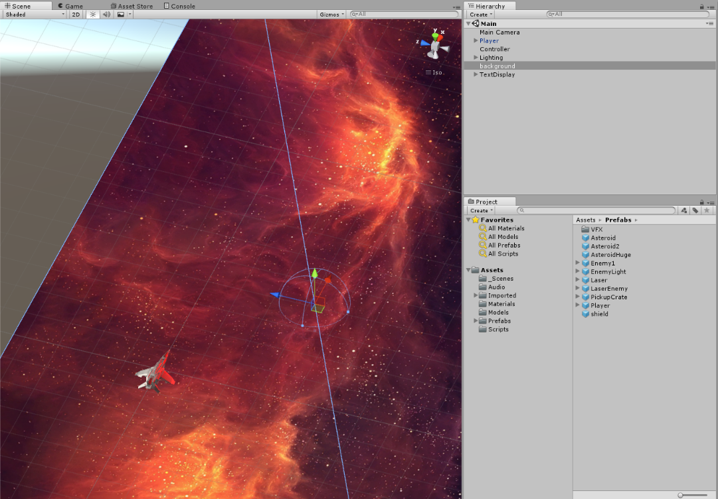

Figure 2 Main character and background, 3D space

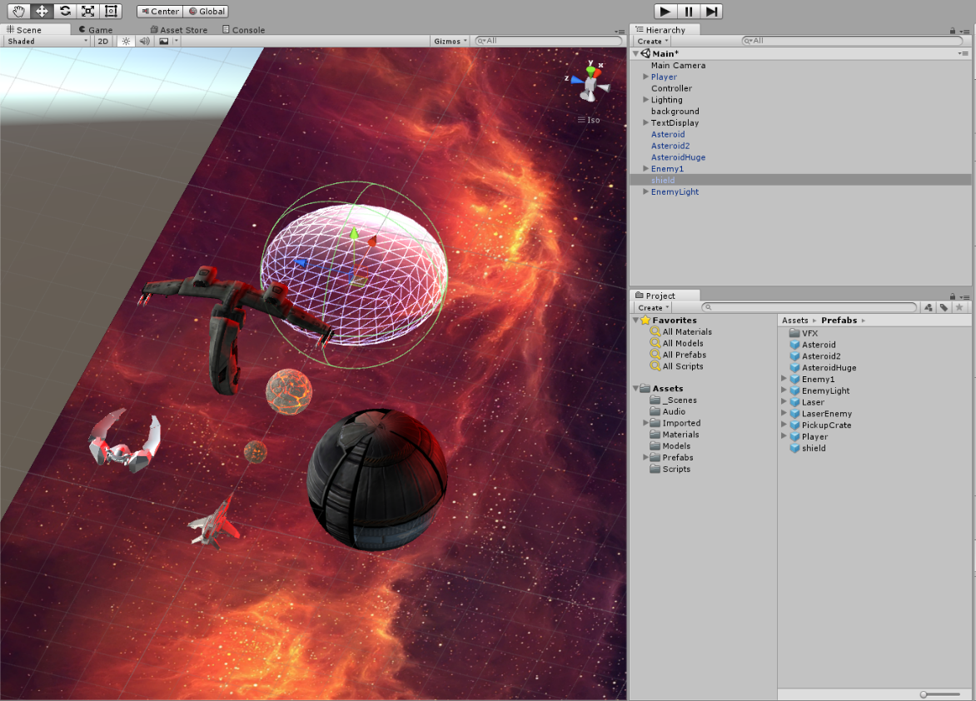

Figure 3 A Selection of Game Objects

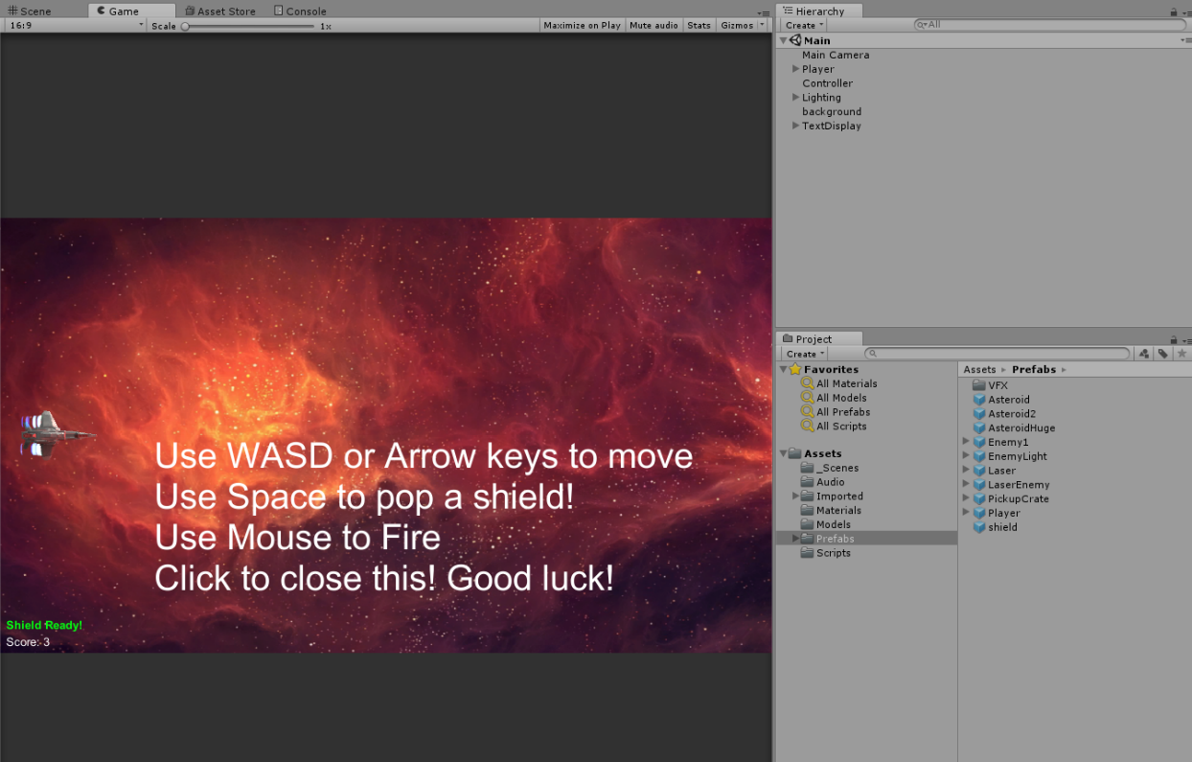

Figure 4 Start game screen

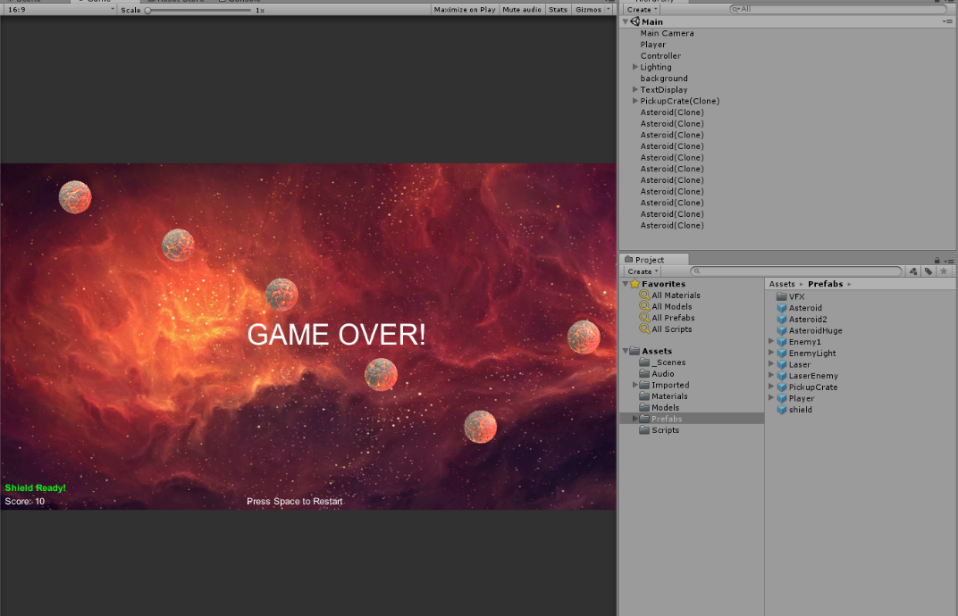

Figure 5 End Game Screen

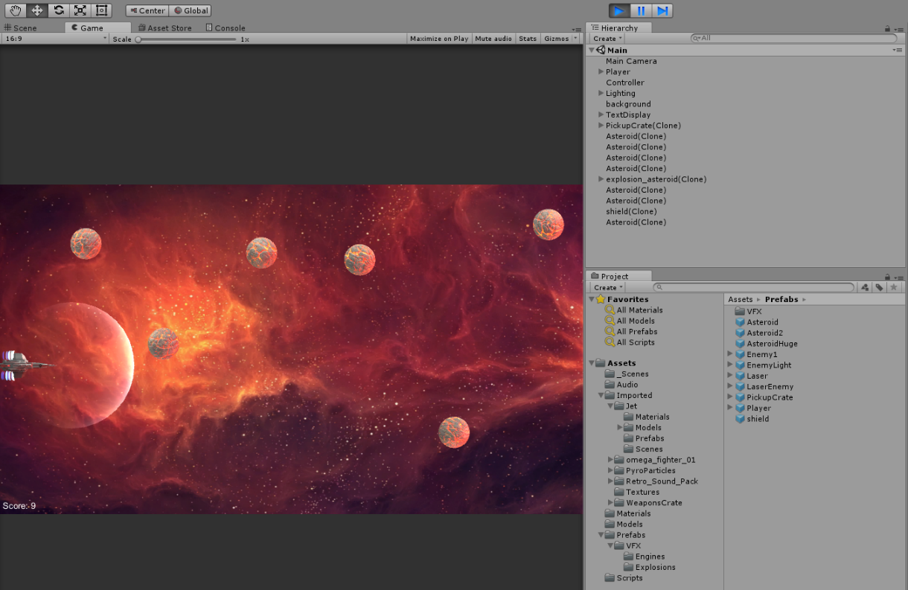

Figure 6 In Game shot

Code Structure

